2022 NH Envirothon Competition Results
2022 Current Environmental Issue Theme: Waste to Resources, A Focus on Plastics in NH

Competing schools: Concord HS, ConVal HS, Goffstown HS, Moultonborough HS, Prospect Mountain HS, Timberlane HS, White Mountain HS and Kingswood MS.

The 2022 NH Envirothon competition was held at NHTI in Concord, NH on May 17.
- 70 students and 12 coaches
- 21 seniors received honor cords.
- 45 volunteers (mainly scientists and experts in Natural Resources) planned and ran the competition day.

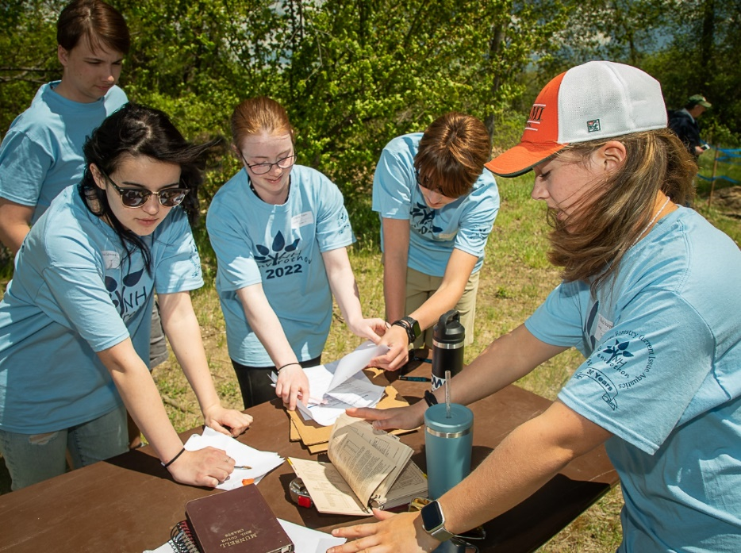

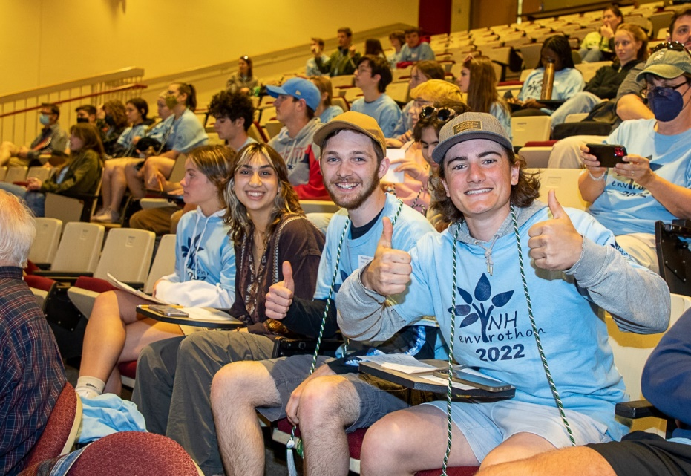

NHE 30th NHE Anniversary Year!
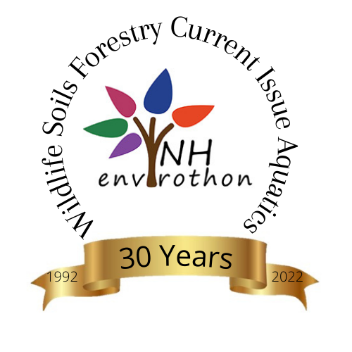

The 2021-2022 NHE Steering Committee Leaders:
Judy Tumosa – Aquatic Ecology
John Slater – Current Environmental Issue
Dawn Dextraze – Forestry
Peter Whitcomb – Soils and Land Use
Maria Colby – Wildlife.

SCLs met bimonthly with the Program Coordinator, headed teams of 4-6, planned and implemented training and testing materials.

2022 NHE Results:
- 1st Overall in NH – Goffstown HS team 9

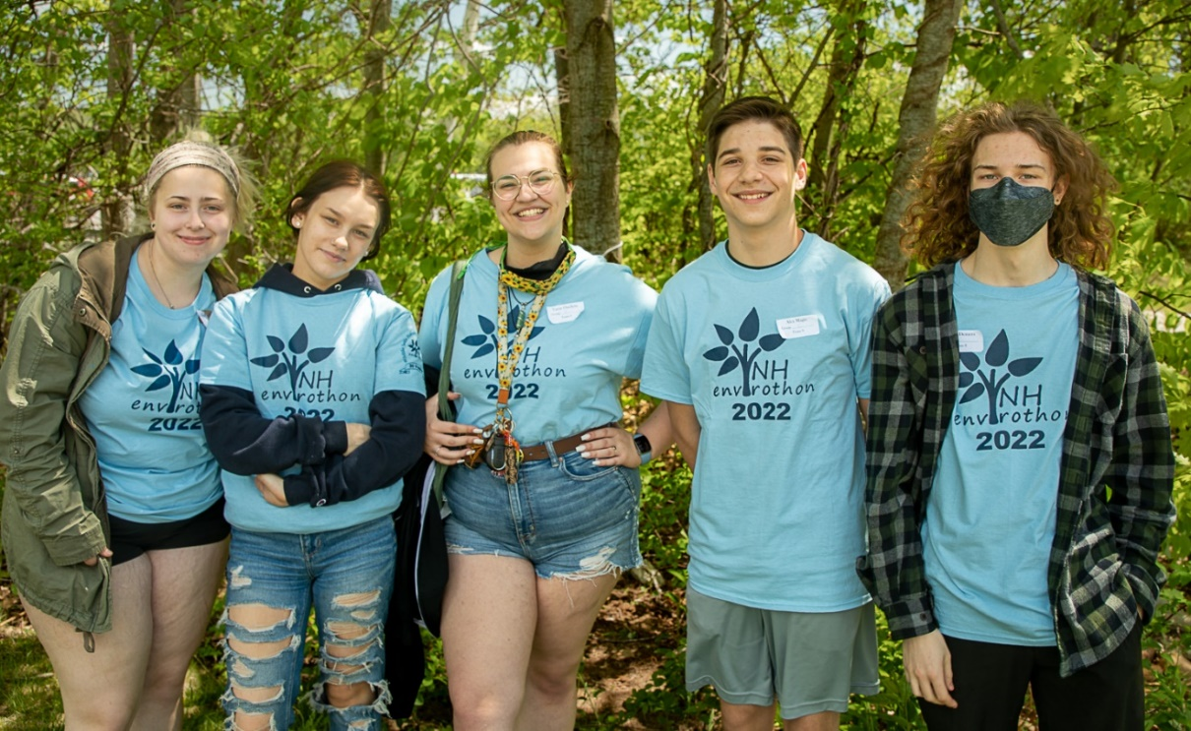

- 2nd Overall in NH – Goffstown HS team 5

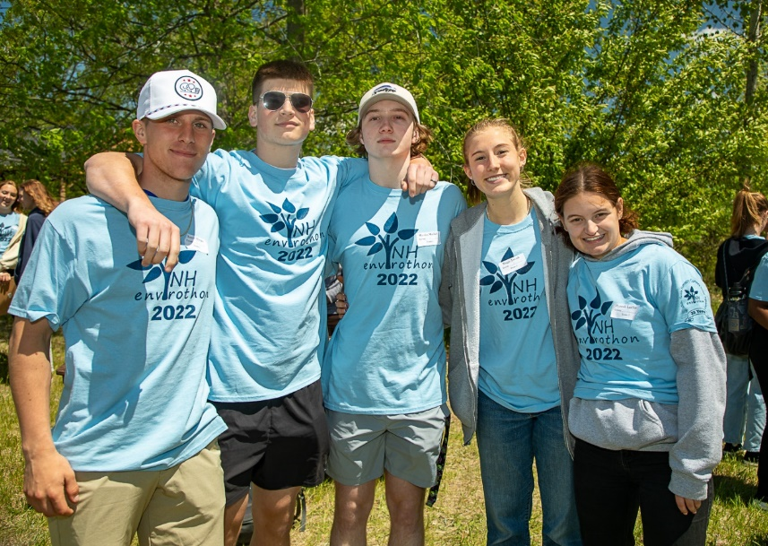
- 3rd Overall in NH – Timberlane HS team 10

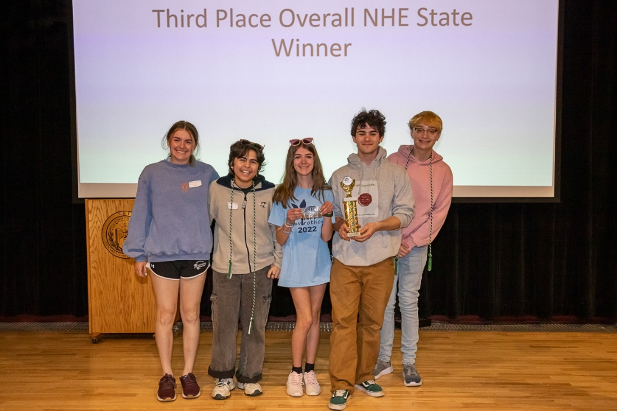

- 1st in Current Issue – Timberlane team 10

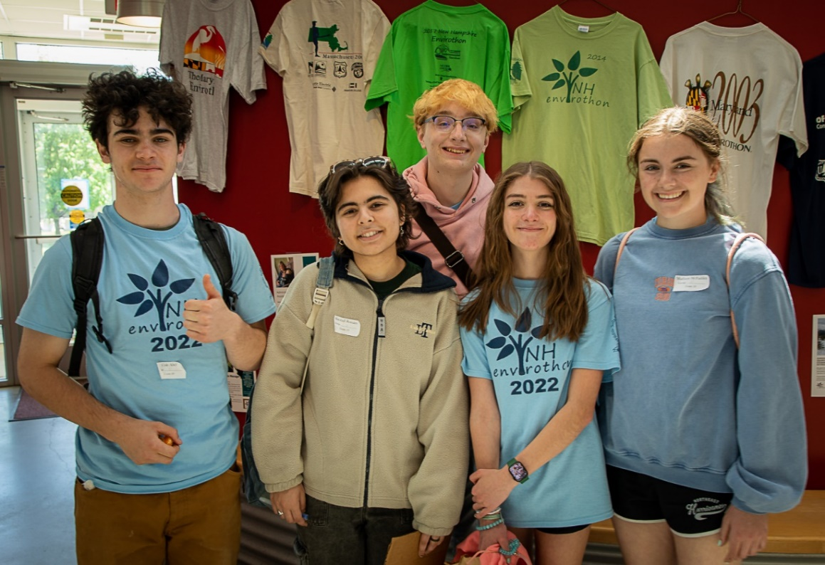

- 1st in Soils – Prospect Mountain team 8

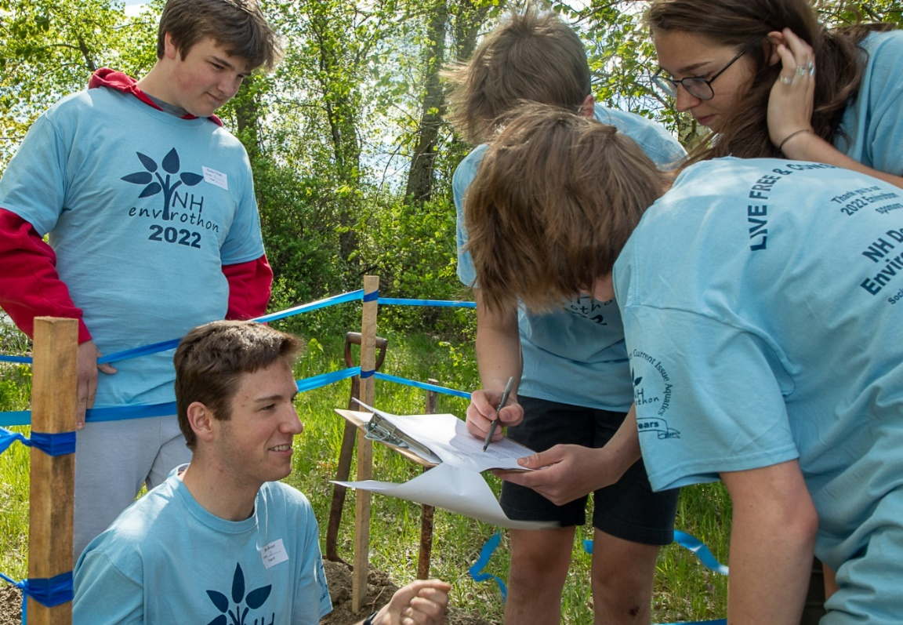

- 1st in Aquatics, Forestry, and Wildlife – Goffstown team 9

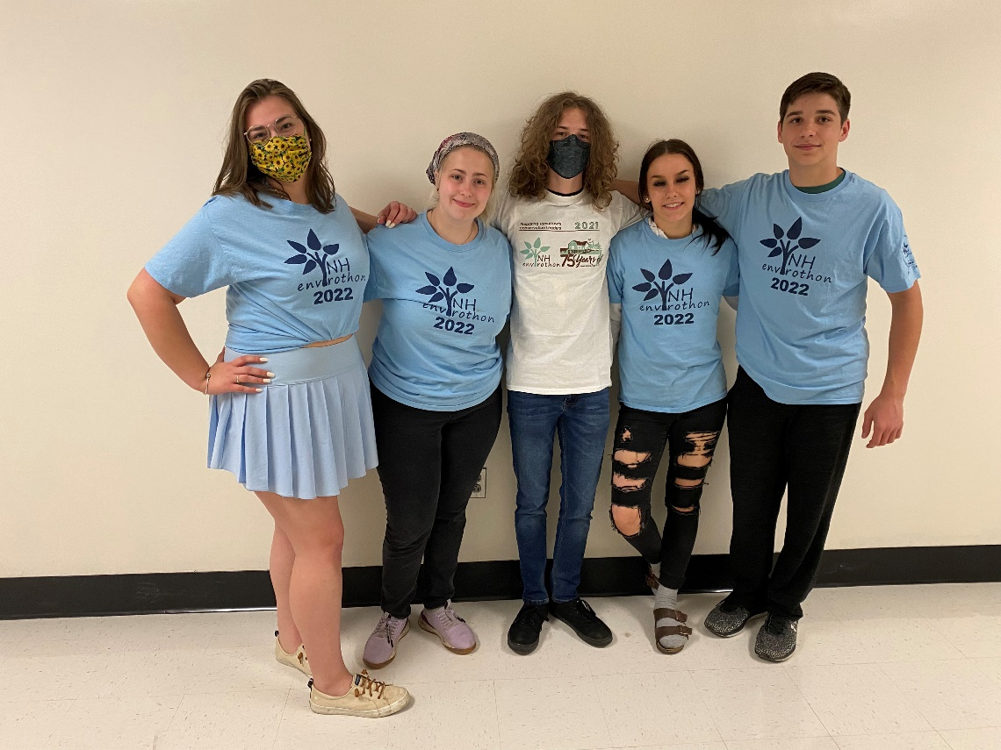

- MS Champion – Kingswood MS

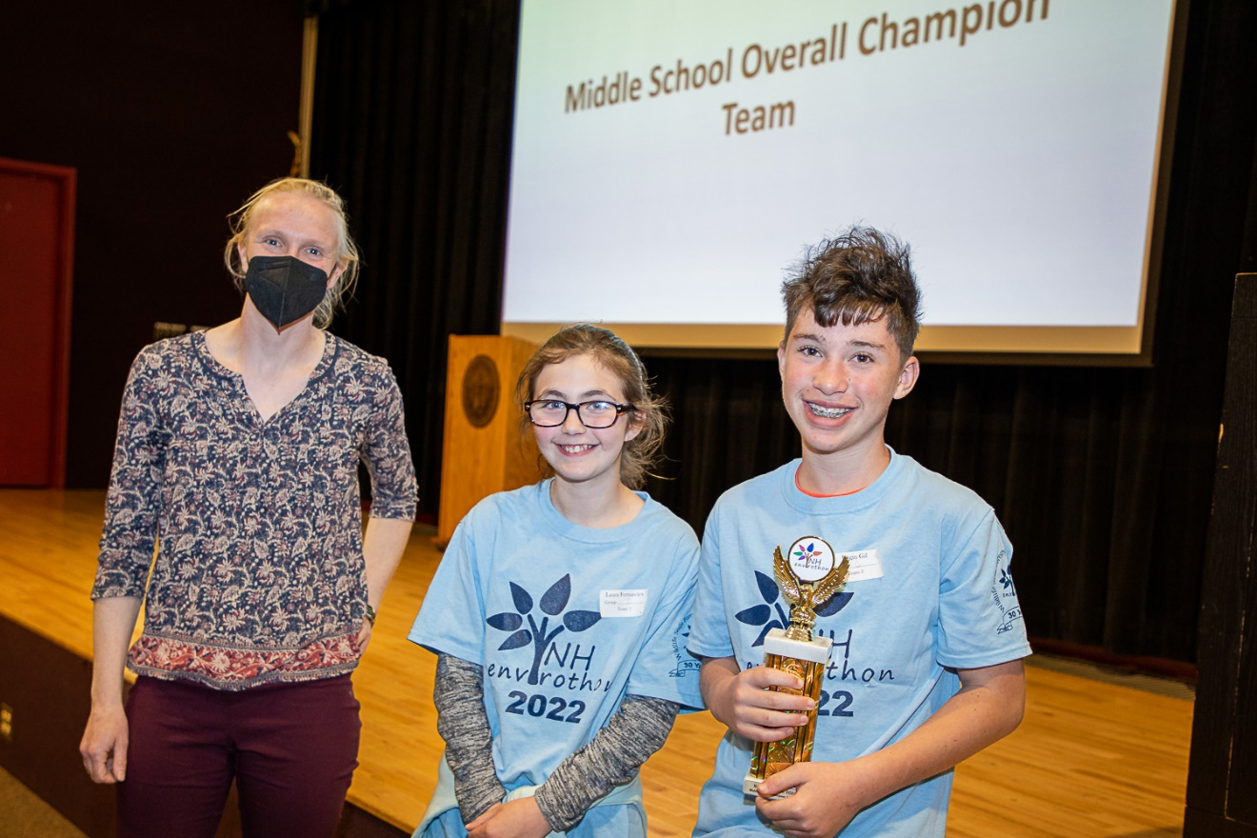

Congratulations to all who challenged themselves, worked all year, and competed at the NH Envirothon!

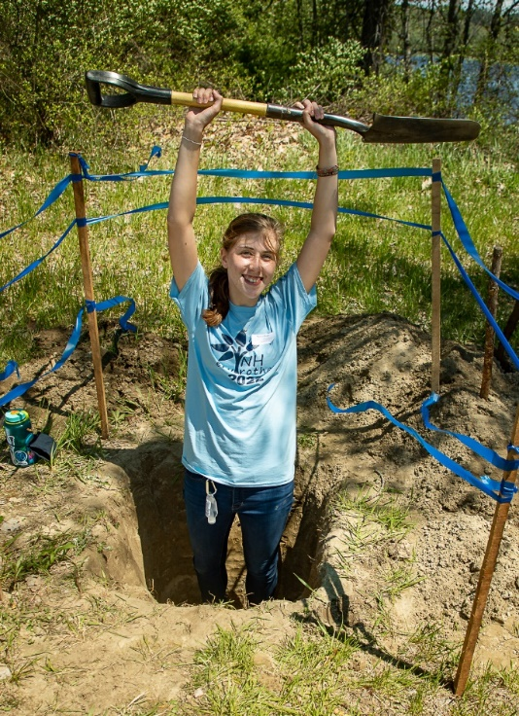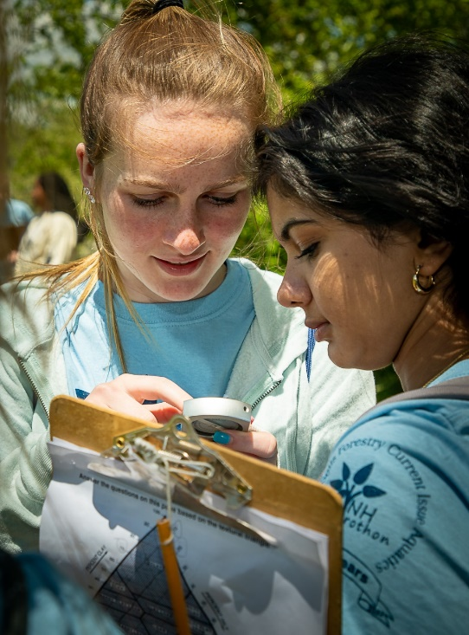
A NH Envirothon Student Recognition Night and Evening of Conservation was held at Delta Dental Stadium in Manchester on June 23, 2022.
Lots of pre-game informative tables and interactive activities were accomplished.
A winning Envirothoner (Go Maddie!) threw out the first pitch.
Then a wonderful evening of watching the NH Fisher Cats play their baseball game finished off the event on a beautiful summer’s evening.
Many thanks to those sponsors and people who made this memorable night happen!

